Rain-Based Irrigation Optimization Dashboard
Project Proposal
Developer: Chitra Vinaya Kumar
Target Audience: Home and business owners and gardeners in Louisville, KY
Technology Stack: Python, Open-Meteo API, Power BI
Introduction
Water conservation is increasingly important for homeowners, gardeners, and sustainability-focused communities. Many people rely on fixed watering schedules or guesswork, which leads to overwatering, underwatering, and unnecessary water waste. A data-driven irrigation assistant can help users make smarter decisions by using real-time weather data and automated recommendations.
This project proposes a weather-aware irrigation system that retrieves daily weather forecasts, applies rule-based irrigation logic, and delivers actionable insights through an interactive dashboard. To increase usability and real-world value, the system will also send automated daily email notifications advising users whether to water or skip watering based on forecasted rainfall.
Problem Statement
Homeowners and gardeners lack an automated, data-driven method to determine whether watering is necessary on a given day. Without timely insights or notifications, irrigation decisions are inefficient, inconsistent, and often wasteful.
Objectives
This project will:
- Extract daily weather data from the Open-Meteo API using Python
- Transform raw JSON into clean, structured tabular data
- Apply rule-based irrigation logic to determine Water / Skip recommendations
- Store processed data in CSV format for dashboard consumption
- Build an interactive dashboard (Dash or Power BI) showing:
  - 7-day forecast
  - Precipitation probability
  - Irrigation recommendation
  - Key weather metrics
- Send automated daily email notifications summarizing:
  - Today’s weather
  - Rain probability
  - Expected rainfall
  - Water / Skip recommendation
- Automate the entire pipeline to run daily
Technical Approach
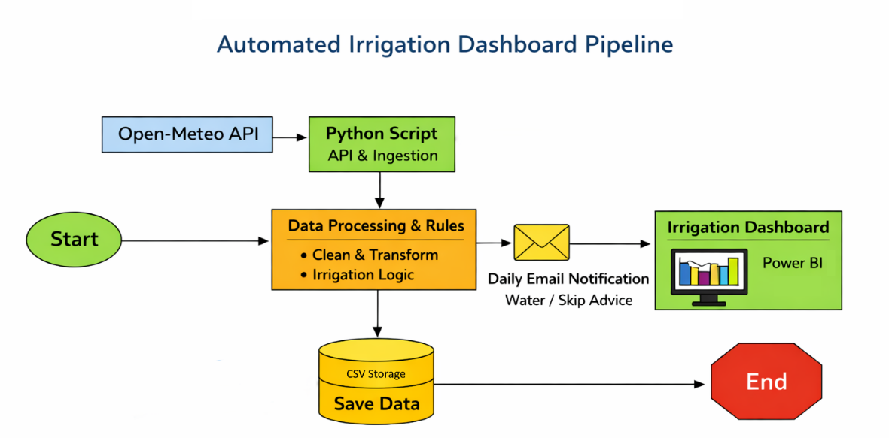

- Data Source
- API: Open-Meteo Weather Forecast API
- Location: Louisville, KY
- Parameters: temperature, precipitation probability, precipitation amount, weather code, humidity, wind speed
- Tools & Technologies
- Python: requests, pandas, smtplib (email), cron
- Storage: CSV files
- Visualization: Power BI
- Automation: Cron
3. ETL + Notification Workflow
1. Extract
- Call Open-Meteo API daily
- Retrieve hourly and daily forecast data
2. Transform
- Convert JSON to pandas DataFrame
- Clean and rename columns
- Map weather codes to readable descriptions
- Apply irrigation rules:
  - If precipitation probability > 50% → Skip watering
  - If rainfall in last 24 hours > 0.1 in → Skip watering
  - Else → Water
3. Load
- Save cleaned data and recommendation to CSV
Notify
- Generate a daily summary email including:
  - Today’s temperature
  - Rain probability
  - Expected rainfall
  - Water / Skip recommendation
- Send the email automatically at a scheduled time (e.g., 6 AM)
Timeline
Week | Tasks
Week 1 | Select API, finalize proposal, test API calls, set up project structure
Week 2 | Build extraction + transformation pipeline, implement weather code mapping
Week 3 | Add irrigation logic, finalize CSV storage, implement email notification
Week 4 | Build dashboard (Power BI), create charts and KPIs
Week 5 | Testing, performance tuning, documentation, final presentation

Expected Outcomes
By the end of the project, the deliverables will include:
- A fully functioning ETL pipeline that retrieves and processes weather data
- A rule-based irrigation recommendation engine
- A clean CSV dataset updated daily
- An automated daily email notification system
- An interactive dashboard showing weather trends and watering recommendations
- A future-ready architecture that can integrate with smart sprinkler systems
- A final presentation summarizing insights, workflow, and results
Conclusion
This project provides a realistic, manageable, and meaningful application of data engineering skills. It demonstrates the full lifecycle of a modern data pipeline—from API ingestion to automated recommendations to interactive visualization. The addition of daily email notifications increases real-world usefulness, and the architecture naturally supports future integration with smart sprinkler systems for full irrigation automation.

